# Overview

In this guided practice you will download and deploy the software in our software share using group policy.

# Objectives

* Configure Group Policy settings and processing
  + Create and manage group policy objects.
  + Link group policy objects.
  + Configure a software distribution point.
  + Publish software using group policy.
  + Assign software to users or computers using group policy.

## Skills Reviewed

* Managing Group Policy processing.
* Creating and linking group policy objects.
* Verifying group policy settings.

## New Skills

* Publishing software using group policy.
* Assigning software using group policy.

# Initial Conditions

Guided Practice - **Creating Active Directory Objects** is complete.

# Final Conditions

* **Chrome** MSI package assigned to all computers in the domain.
* **MBSA** MSI package published to all users in the domain.
* **7zip** package assigned to all computers in the domain.
* MSI files for **Chrome**, **MBSA**, and **7zip** exist in their own folders in the **C:\Shares\Software** folder.

# Instructions

## Setup

1. Login to the **Server-01** virtual machine
2. Open the **GPMC.**
3. **Disable** grouppolicyinheritance **blocking** on the **Greenville** **Administration** OU.
4. **Remove** the enforcement of the **Application Deny List** policy at the domain.

## Publishing software with group policy

Publishing software using group policy allows users to install software on demand. The software does not get automatically installed. The user must choose to install the software from the Programs and Features applet in the control panel

**Publish** the **MBSA** software using group policy by performing the following:

1. Logon to the **Server-01** virtual machine (**DC-01**) using the **KMWadmin** account.
2. 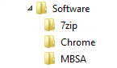Create folders named **Chrome**, **7zip**, and **MBSA** **in** the **C:\shares\software** folder.
3. Download the **7-zip**, **MBSA**, and **Google** **Chrome** msi files from the course website and place them in the associated folders that you created above.
4. Open the **Group Policy Management Console.**
5. Navigate to the **Forest: KMW.localàDomainsàKMW.local**
6. Select **Create a GPO in this domain and Link it here…** from the **context menu** for **KMW.local.**
7. In the **New GPO** dialog box, **name** the Group Policy – **KMW Software Installation** andclick **OK**.
8. Right**-**click the policy you created and select **Edit** from the context menu.
9. 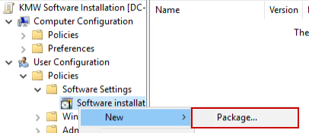Navigate to the **User Configuration à Policies à Software Settings** node.
10. Select **NewàPackage…** from the **Software installation context** menu.
11. In the **address bar** for the file browser type **\\DC-01.KMW.local\software**.
12. Browse to the **MBSA folder** and select the **MBSA installer package,** as shown in the figure, and click **Open**.
13. 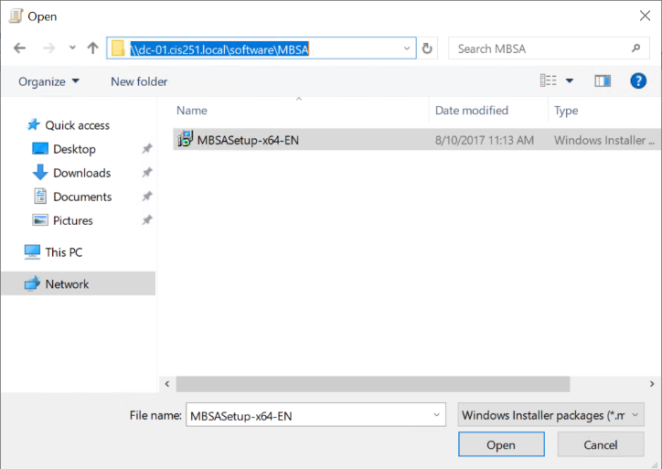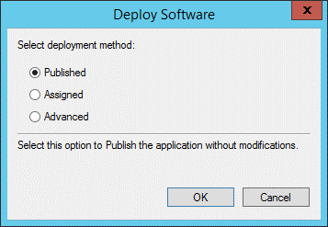In the **Deploy Software** dialog box verify that **Published** is selected and click **OK**.
14. 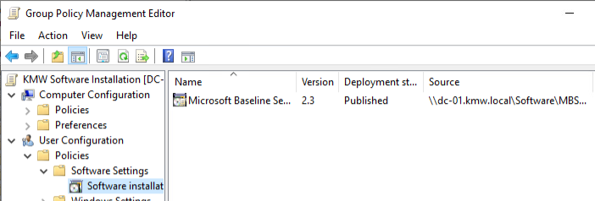Verify that the package shows in the display window as shown below.
15. Close the **Group Policy Management Editor**.

Verify the software has been published using the steps below:

1. Start the **Client-01** or **Client-02** virtualmachine and **logon** as **Sharon Fisher (**shfisher**)**.

**Note**: If you are signed in already you will need to sign out and sign back in to refresh the group policy settings or wait until the default refresh interval ~ 45 minutes.

1. Open the **Programs and Features** applet in the control panel.
2. Choose the **Install a program from the network** option.

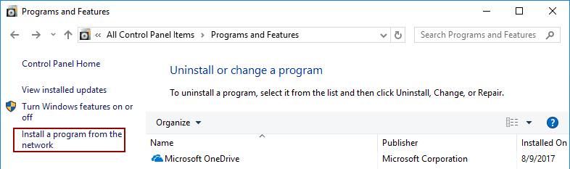

1. You should see the screen below that will allow you to **install Microsoft Baseline Security Analyzer** on your machine.

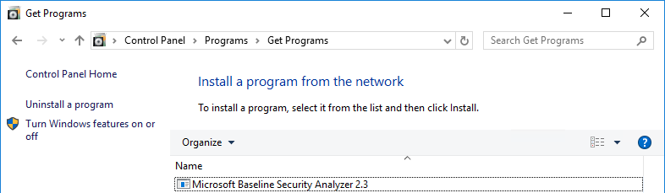

1. Selectandinstall **Microsoft Baseline Security Analyzer** to test the remaining settings.

## Assigning Software to Users

Assigning software to users through Group Policy will result in the software being installed on the machine when a user logs on. In this step, you will assign the 7zip software to all the users in the domain

Assign the **7zip** software to all users using **Group Policy** by performing the following:

1. Logon to the **Server-01** virtual machine using the **KMWadmin** account.
2. Open the **Group Policy Management Console.**
3. Navigate to the **Forest: KMW.local à Domains à KMW.local.**
4. Editthe **KMW Software Installation** policy**.**
5. Navigate to the **User Configuration à Policies à Software Settings** node.
6. Select **New à Package…** from the Software installation context menu .
7. In the addressbar for the file browser type **\\DC-01.KMW.local\software**.
8. Browse to the **7zip folder** and select the **7zip installer package** and click **Open**.
9. In the **Deploy Software** dialog box verify that **Assigned** is selected and click **OK**.
10. 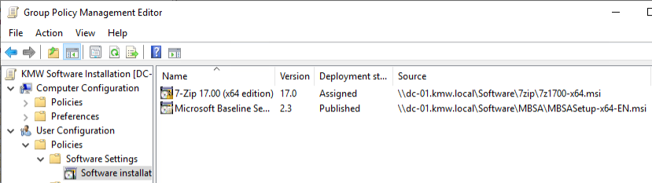Verify that the package shows in the display window as shown below.
11. To configure the software to install at logon, right-click the **7zip** entry and select properties from the context menu as shown in the figure.
12. 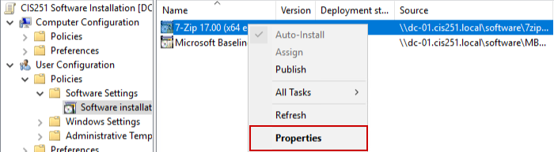In the **7zip Properties** dialog box, select the **Deployment** tab and select the **Install this application at logon** option, then click the **OK** button as shown.
13. 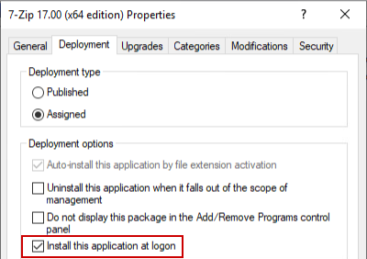Browse to the **Computer Configuration à Policies à Administrative Templates à System à Logon.**
    1. Enable the **Always wait for the network at computer startup and logon** policy, this will force the computer to process your group policy objects at startup or logon, which may slow things down some but will minimize the number of reboots required to get software installed.
14. You may also wish to turn on the group policy for verbose messages. This will give you detailed messages about what is occurring during startup and logon. To turn this setting on perform the following:
    1. In the GPO, browse to the **Computer Configuration à Policies à Administrative Templates à System.**
    2. Enable the **Display highly detailed status messages** policy.
15. Close the **Group Policy Management Editor**.

Verify the software has been installed using the steps below:

1. Logonto the **Client-01** or **Client-02** virtual machine as **Sharon Fisher (**shfisher**)**.
2. Verify that **7zip** is **installed,** you should see an icon on the **Start** menu.
3. If **7zip** did not install, perform the following:
   1. Open PowerShell.
   2. Type **gpupdate /force.**
   3. Sign out and sign back in or restart if prompted.

## Assigning Software to a Computer

1. Use the steps above to **assign** the **Chrome** software to the computers in the domain.

**Note**: the procedure is the same except you configure the settings in the **Computer Configuration** node.

1. Give **Client-01** and **Client-02** the **Read** permission on the **Software** share on **DC-01**.
2. Verify that the software installs by rebooting the **Client-02** computer and verify that the software is installed on the system.
3. You also may need to reboot your system a few times before it installs the software.

## Submission Requirements

1. **Download** the **grading** **script** from the assignment page to the **C:\Scripts** folder.
2. Check your lab by running the following command:

Invoke-Pester -Path C:\Scripts\GP20-Deploying_Software_wth_Group_Policy.test.ps1

**Note**: You will see a security warning when running the script. Enter **R** to run the script.

If you want to see more detail, add **-Output Detailed** to the command. This may assist you with troubleshooting

Invoke-Pester -Path C:\Scripts\GP20-Deploying_Software_wth_Group_Policy.test.ps1  
-Output Detailed

1. You should not see any red in the output. Red in the PowerShell way of telling you that an error condition exists. Most of the time, the output will tell you what is wrong. If it is not obvious, contact your teacher and ask for assistance. You will be learning PowerShell during this term. **Correct** any **errors** you may have and run the script until all the output has no red. You should see the output like the images below.

1. Capture a snippet that shows the PowerShell Command and all its output. If you must use more than one snippet to capture the output, you must have at least **one line of overlap** in the snippets. The text in the snippets **must be legible** when pasted into the Word document. Paste the snippet(s) into a **new** **Word** **document**
2. **Upload** the **document** in the submission area of the assignment.